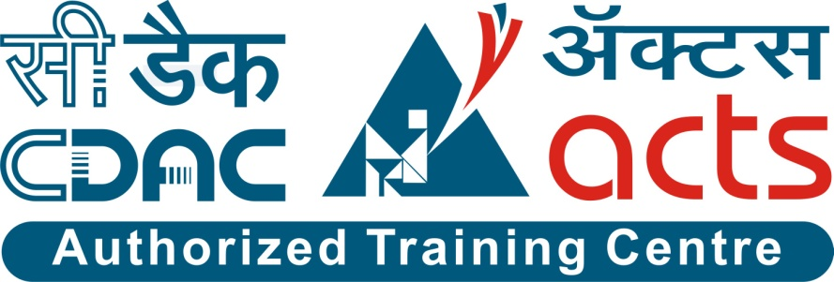

Project Name: Paperless School Management System

Branch E-DAC Sept-2020

Documentation On

**“PAPERLESS SCHOOL MANAGEMENT SYSTEM”**

E-DAC SEPT 2020

**Guided By: Bakul Joshi**

Submitted By :

**Group No: 03**

* **Gayatri Wankhade 200943081029**
* **Kimaya Khilare 200943081038**
* **Mohini Ugave 200943081043**
* **Shilpa Narute 200943081046**
* **Nupur Muley 200943081047**

**Table of Contents**

**1. Introduction 4**

1.1 Document Purpose **4**

1.2 Project Background **4**

1.3 Aim & Objectives **4**

**2. Business Requirements Overview**…………………………………………………………**5**

**3.Functional Requirements** **6**

3.1 Student Module **6**

3.2 Teacher Module **6**

3.3 Admin Module **6**

**4.** **Non-Functional Requirement………………………………………………………………7**

**5. Use Case Diagram 8**

5.1 Admin **9**

5.2 Student **10**

5.3 Teacher **11**

**6. Database Design 12**

1 Student **12**

2 Teacher **12**

3 Login…………………………………………………………………………………… **13**

4 Class **13**

5 Subject **13**

6 Chapter **13**

7 Progress **13**

8 Marks **13**

9 Attendance **14**

10 Query **14**

**7. E-R Diagram………………………………………………………………………………………14**

**8. Snapshots 15**

**9. Conclusion 20**

**List of Figures**

**Use Case Diagrams 17**

Fig 1 Admin 8

Fig 2 Student 9

Fig 3 Teacher 10

Fig 4 ER Diagram 14

1. **Introduction:**
   1. **Document Purpose:**

This document communicates the business requirements and scope for developing Paperless School Management System. The scope of this document is to define the functional and non functional requirements, business rules and other constraints requirements.

## Project Background:

In this pandemic, one of the main things the whole world has understood is power of internet and ability to study or work from home. During this pandemic, education systems in India faced challenge with education process for students. With this challenge in mind, we decided to work on a system where we can completely virtualize or make the educational process such as online school with easy accessibility of resources and study material etc. With advancement in telecom industry, phones are cheaper and internet has reached every corner of villages. Hence giving accessibility of education to the students in every remote and rural part of India.

## Aim & Objectives:

The main objective of this system is building a website which improves user accessibility and time flexibility to earn education no matter where they are located. Basically we are providing features like Study Materials, Maintaining attendance, Generating progress reports etc. The key benefits of online education are low costs , no traveling required , self-paced coursework. It provide all information and services to all faculty members , students and their parents. The online school management system is enabled to manage the performance of the students.

1. **Business Requirements Overview:**

* Paperless School Management is a Web application for various different schools.
* Paperless School Management is opened to the global, but in phase 1, the main target is a single school.
* There are mainly two types of user. One is the Student and other is Teacher.
* Student can go through study materials, see progress card, raising queries etc.
* Assigning Teachers to respective class through Admin only.
* Teacher will maintain attendance, upload study materials and generate progress report.
* Paperless School Management is maintained by Administrator.

Paperless School Management provides such functionalities which connect teachers and the students with each other efficiently and it will reduce gap between teacher and students.

# Functional Requirements Overview:

Paperless School Management System consists of four modules described as below.

1. Student Module
2. Teacher Module
3. Admin Module

# **3.1 Student Module**

* Students will get Login credentials from Admin
* Paperless School Management System provides the functionalities like raising queries, viewing progress report, checking study materials etc.
* The Students can learn the technique how to use Paperless School System.
* The Students can find Attendance report etc.
* Providing “FAQ” in case of any Queries

# **Teacher Module**

* Paperless School Management System provides the functionality which allows Teachers to provide all study materials according to student standards.
* Maintain the attendance and generate progress report for every student.
* Send messages or email to the parents.

# **3.3 Admin Module**

* Paperless School Management System should provide all functionality to admin how to handle the System.
* Admin has controls of all the functionalities of Student and Teacher module.
* Admin will provide Login credentials to Students and Teachers.
* Admin will assign Teacher to particular class.

1. **Non-Functional Requirement:**

* The website should use professional design, look and feel and color scheme.
* Users will have no limitations for accessing the application through Internet. The portal being an internet application, it is difficult specify exact number of visitor or users. Hence we will target the system to support between 5 and 10 million users on launch of phase 1.
* Being a public website, the site must follow general usability guidelines for menus, navigation, colors, links and other actions provided on the screens.
* The system should be designed in such a manner that user will be able to complete tasks in minimum number of steps.

.

## 5. Use-Case Diagram

**5.1 Admin:**

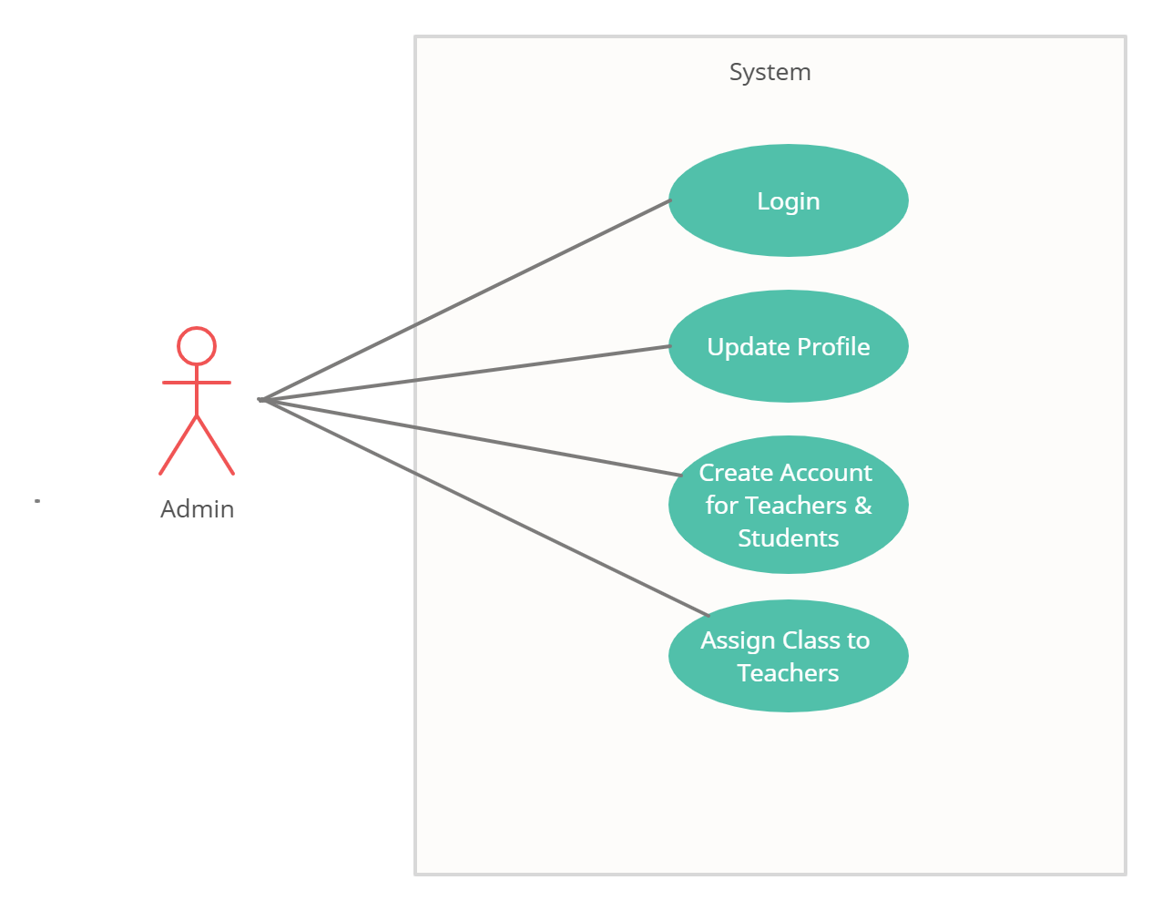

Fig. Use-Case Diagram for Admin

## 5.2 Student:

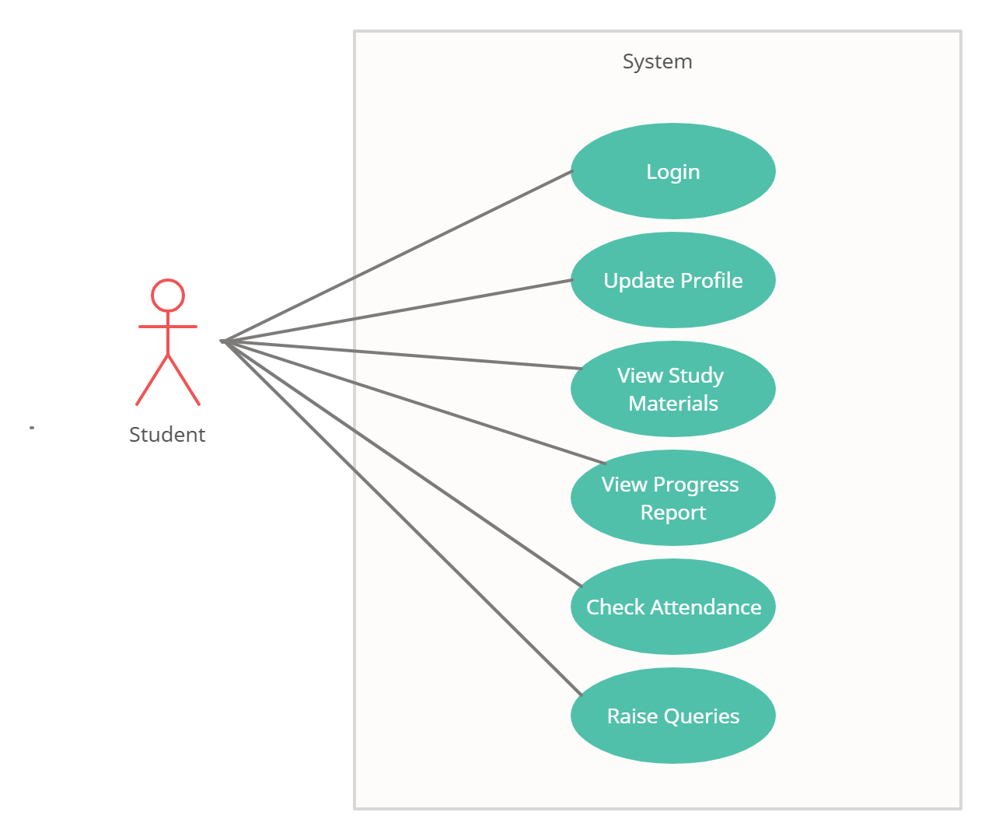

Fig. Use-Case Diagram for Student

**5.3 Teacher:**  
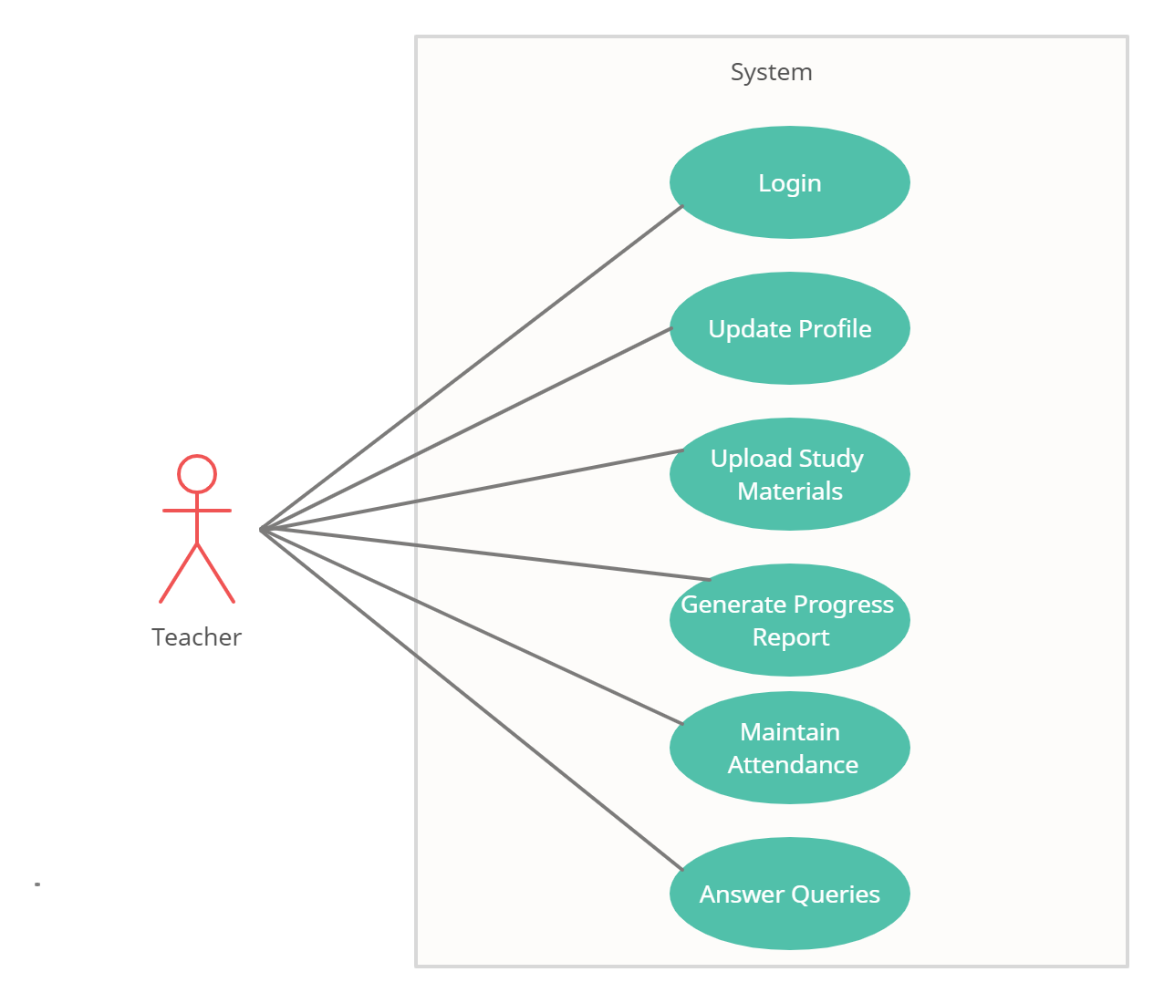

Fig. Use-Case Diagram for Teacher

**6. Database Design:**

**1] student_master table**

|  |  |  |  |  |  |
| --- | --- | --- | --- | --- | --- |
| **Field** | **Type** | **Null** | **Key** | **Default** | **Description** |
| s_id | Integer | No | PK | AI | Student ID |
| user_id | Integer | No |  |  | Student ID-2021001 |
| first_name | Varchar(45) | No |  |  | First Name |
| middle_name | Varchar(45) | No |  |  | Middle Name |
| last_name | Varchar(45) | No |  |  | Last Name |
| email | Varchar(45) | No |  |  | Email ID of Parent |
| contact_no | Varchar(45) | No |  |  | Contact No. of Parent |
| address | Varchar(100) | No |  |  | Permanent Address |
| dob | Date | No |  |  | Date of Birth |
| class_id | Integer | No | FK |  | Class ID |

**2] teacher_master table**

|  |  |  |  |  |  |
| --- | --- | --- | --- | --- | --- |
| **Field** | **Type** | **Null** | **Key** | **Default** | **Description** |
| t_id | Integer | No | PK | AI | Teacher ID |
| user_id | Integer |  |  |  | Teacher ID-1001 |
| first_name | Varchar(45) | No |  |  | First Name |
| last_name | Varchar(45) | No |  |  | Last Name |
| email | Varchar(45) | No |  |  | Email ID of Teacher |
| contact_no | Varchar(45) | No |  |  | Contact no of Teacher |
| qualification | Varchar(45) | No |  |  | Qualification of Teacher |
| address | Varchar(100) | No |  |  | Address |

**3] login_master table**

|  |  |  |  |  |  |
| --- | --- | --- | --- | --- | --- |
| **Field** | **Type** | **Null** | **Key** | **Default** | **Description** |
| login_id | Integer | No | PK | AI | Login ID-1 |
| user_id | Integer | No | FK |  | User ID |
| password | Varchar(45) | No |  |  | Password |
| user_type | Varchar(45) | No |  |  | User Type |

**4] class_master table**

|  |  |  |  |  |  |
| --- | --- | --- | --- | --- | --- |
| **Field** | **Type** | **Null** | **Key** | **Default** | **Description** |
| class_id | Integer | No | PK |  | Class ID- 10,20….. |
| standard | Varchar(15) | No |  |  | Standard-I,II,III,IV…… |
| t_id | Integer | No | FK |  | Teacher ID |

**5] subject_master table**

|  |  |  |  |  |  |
| --- | --- | --- | --- | --- | --- |
| **Field** | **Type** | **Null** | **Key** | **Default** | **Description** |
| subject_id | Integer | No | PK | AI | Subject ID-101,102….. |
| subject_name | Varchar(45) | No |  |  | Subject Name |
| class_id | Integer | No | FK |  | Class ID |

**6] chapter_master table**

|  |  |  |  |  |  |
| --- | --- | --- | --- | --- | --- |
| **Field** | **Type** | **Null** | **Key** | **Default** | **Description** |
| c_id | Integer | No | PK | AI | Chapter ID |
| chapter_id | Integer |  |  |  | Chapter ID |
| chapter_name | Varchar(45) | No |  |  | Chapter Name |
| content | Varchar(2000) | No |  |  | Chapter Content |
| subject_id | Integer | No | FK |  | Subject ID |

**7] progress_master table**

|  |  |  |  |  |  |
| --- | --- | --- | --- | --- | --- |
| **Field** | **Type** | **Null** | **Key** | **Default** | **Description** |
| progress_id | Integer | No | PK | AI | Progress Report ID |
| comment | Varchar(45) | No |  |  | Comment/Suggestions |
| s_id | Integer | No | FK |  | Student ID |

**8] marks_master table**

|  |  |  |  |  |  |
| --- | --- | --- | --- | --- | --- |
| **Field** | **Type** | **Null** | **Key** | **Default** | **Description** |
| mark_id | Integer | No | PK | AI | Marks ID |
| out_of_marks | Integer | No |  |  | Out of Marks |
| obtain_marks | Integer | No |  |  | Obtain Marks |
| subject_id | Integer | No | FK |  | Subject ID |
| progress_id | Integer | No | FK |  | Progress ID |

**9] attendance_master table**

|  |  |  |  |  |  |
| --- | --- | --- | --- | --- | --- |
| **Field** | **Type** | **Null** | **Key** | **Default** | **Description** |
| attendance_id | Integer | No | PK | AI | Attendance ID |
| date | Date | No |  |  | Date |
| remark | Varchar(10) | No |  |  | Remarks(P/A) |
| s_id | Integer | No | FK |  | Student ID |

**10] query_master table**

|  |  |  |  |  |  |
| --- | --- | --- | --- | --- | --- |
| **Field** | **Type** | **Null** | **Key** | **Default** | **Description** |
| query_id | Integer | No | PK | AI | Query ID |
| question | Varchar(100) | No |  |  | Question raise by Student |
| answer | Varchar(500) | No |  |  | Answer given by Teacher |
| subject_id | Integer | No | FK |  | Subject ID |
| s_id | Integer | No | FK |  | Student ID |

## 7. ER-Diagram:

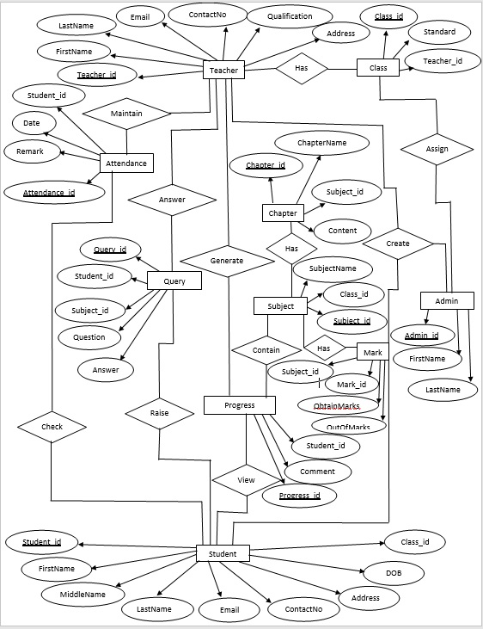

**E-R diagram shows database of Paperless School Management System**

**8. Snapshots:**

**8.1 Home Page:**

Following snapshot shows the Home page for Paperless School Management System

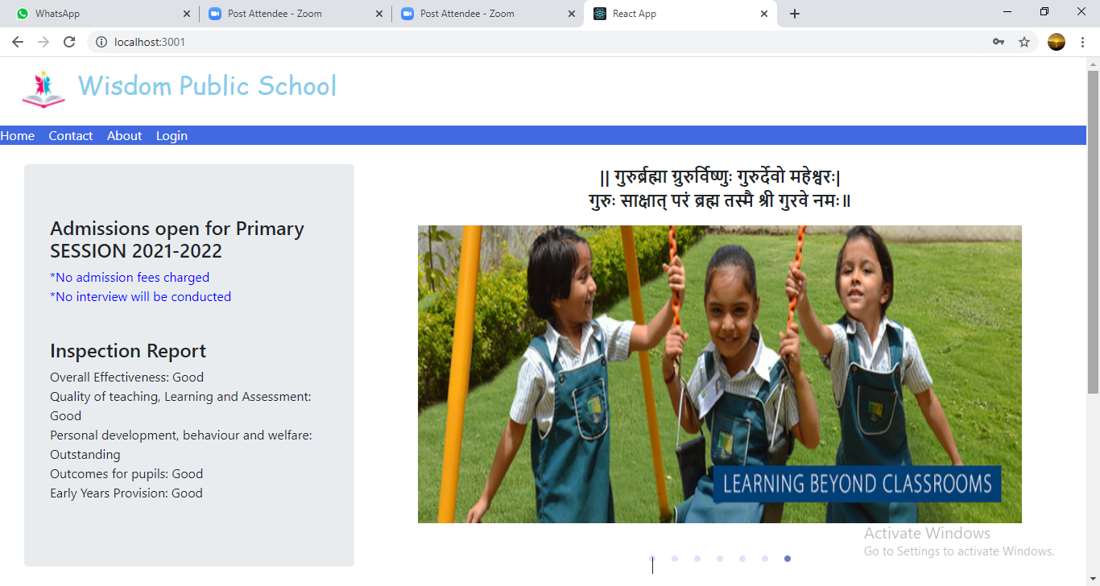

This page contains following controls

* Home
* Contact
* About
* Login Button

**8.2 Contact Page**

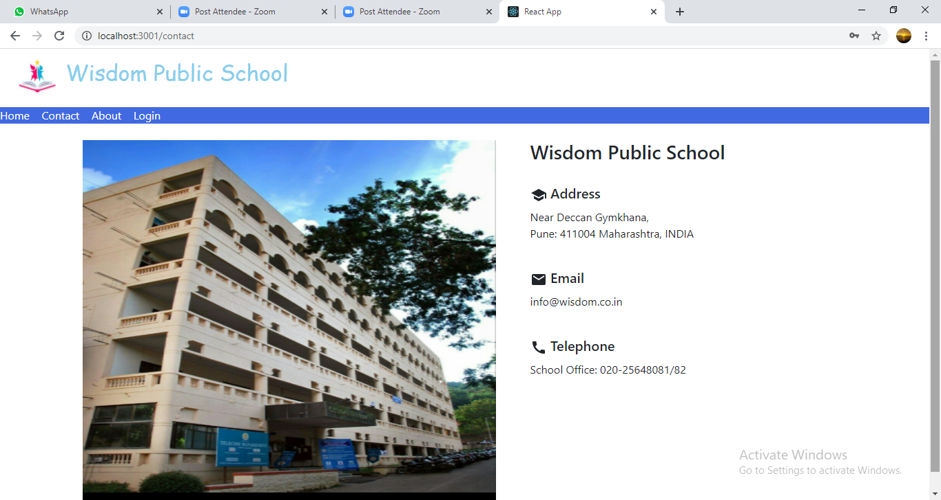

**8.3 About Page**

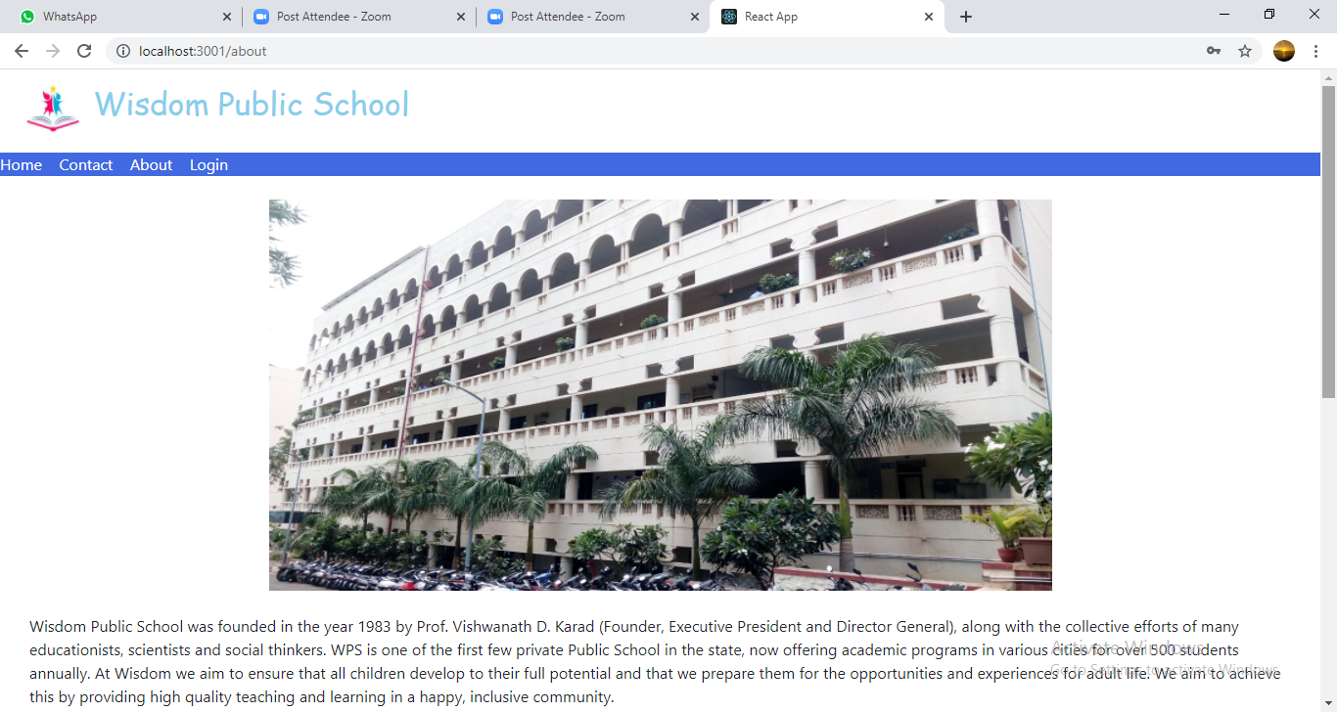

**8.4 Login Page**

Following snapshot shows the Login page for Blood Donation System

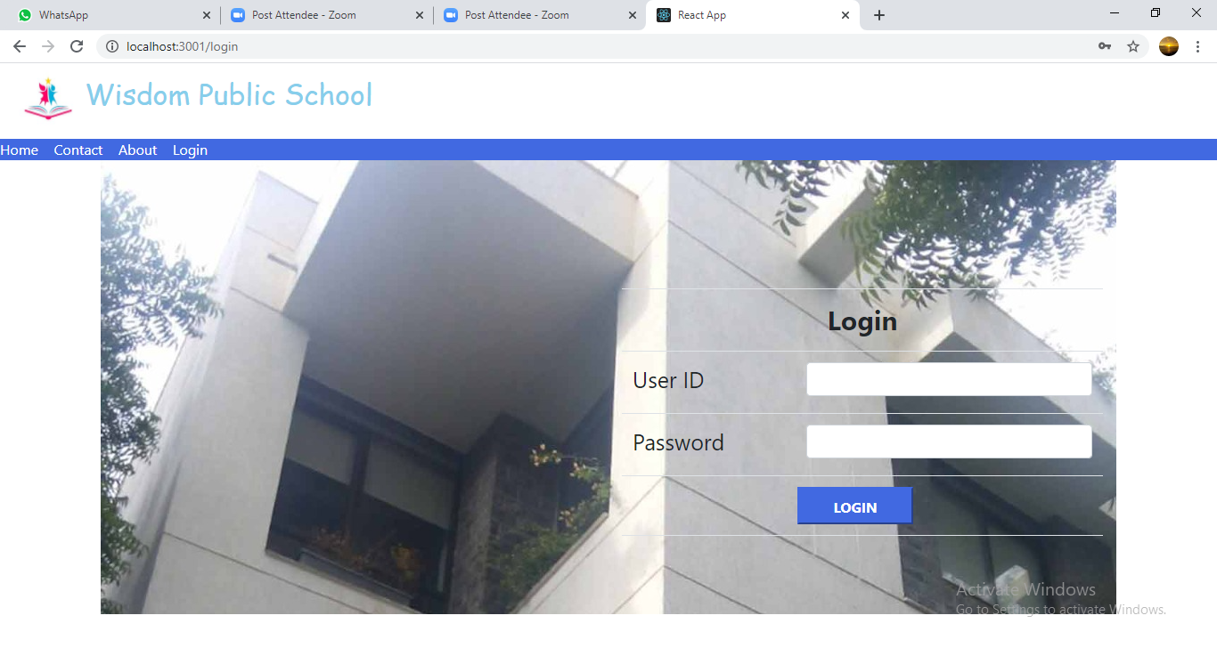

**8.5 Admin Home Page**

**8.5.1 Student Registration Page**

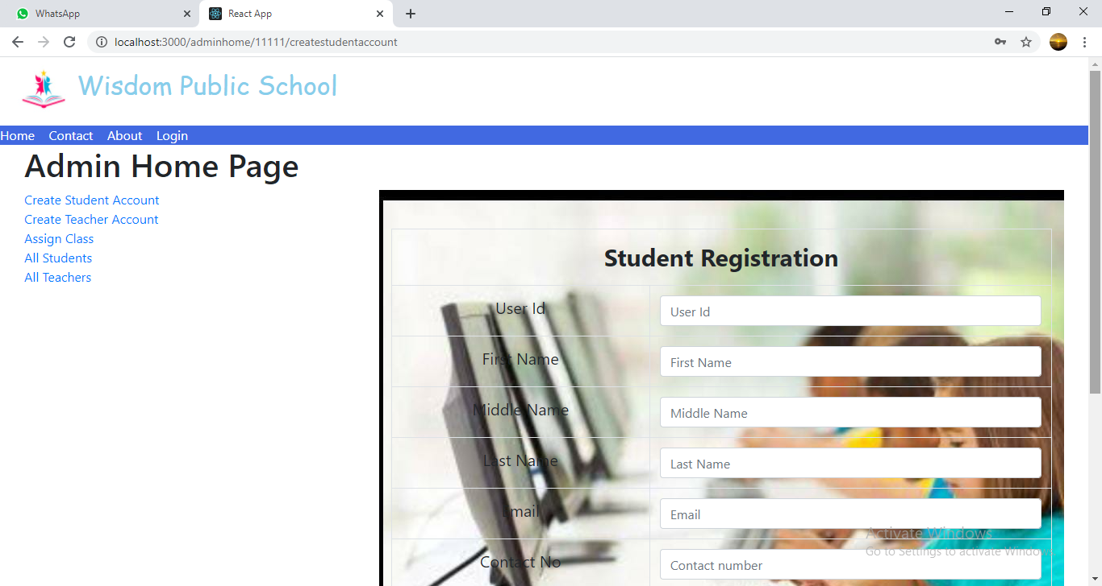

**8.5.2 Teacher Registration Page**

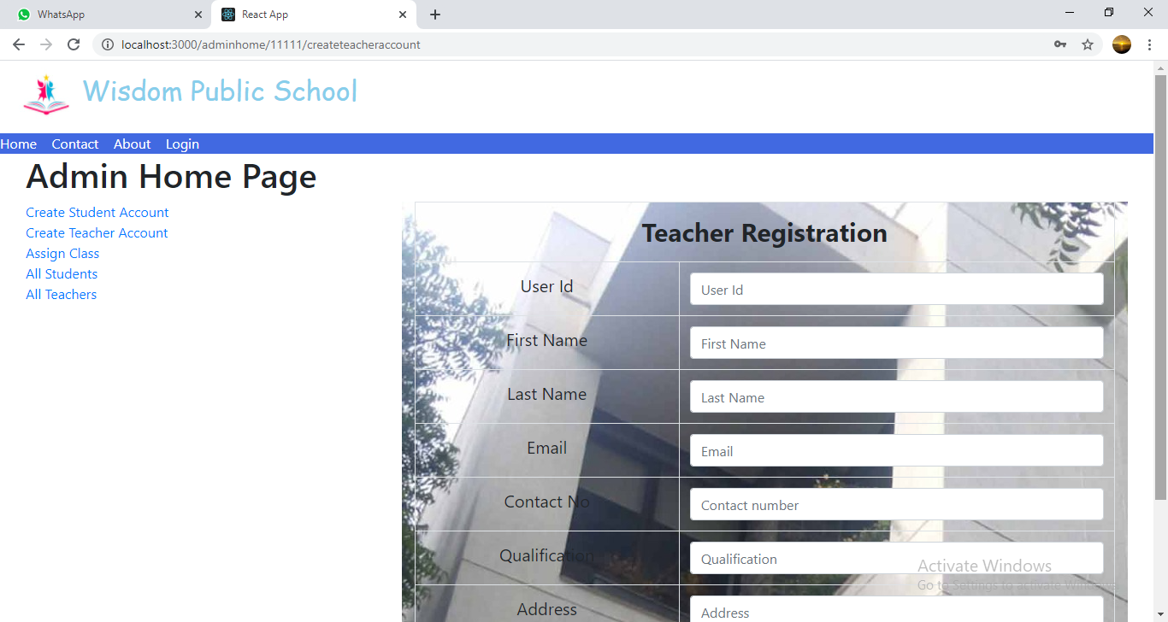

**8.5.3 Assign Class Page**

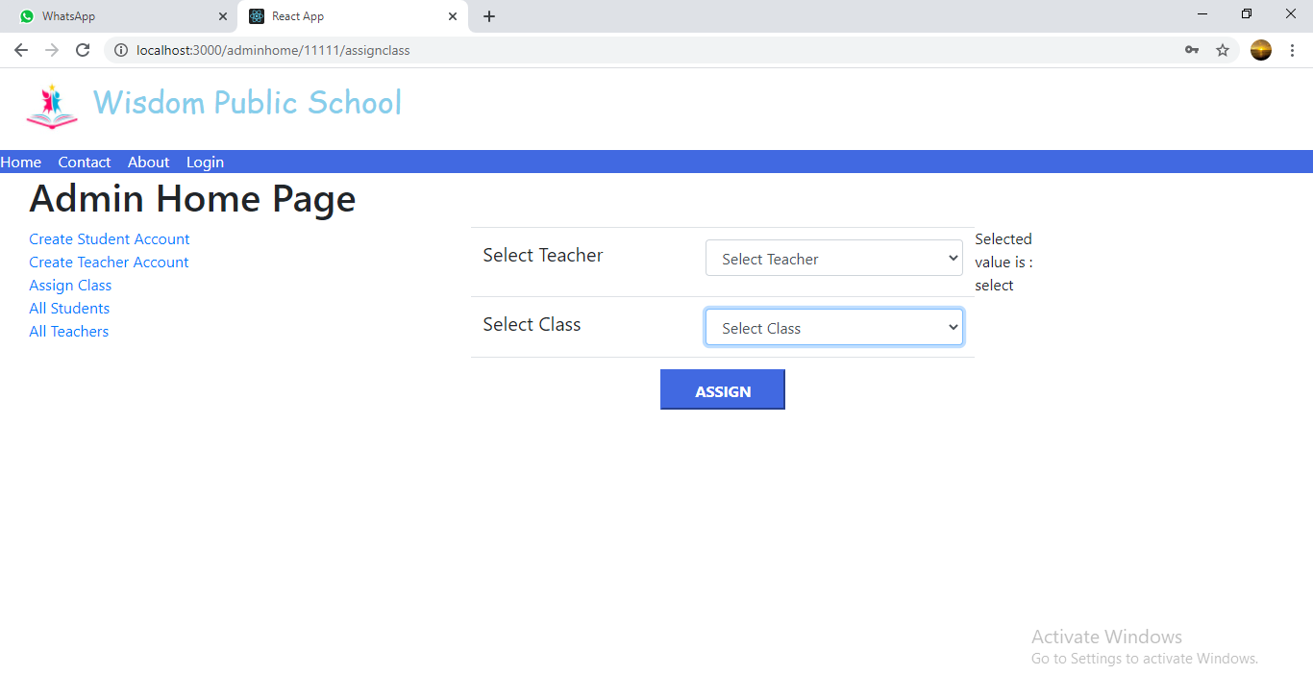

**8.5.4 All Students List**

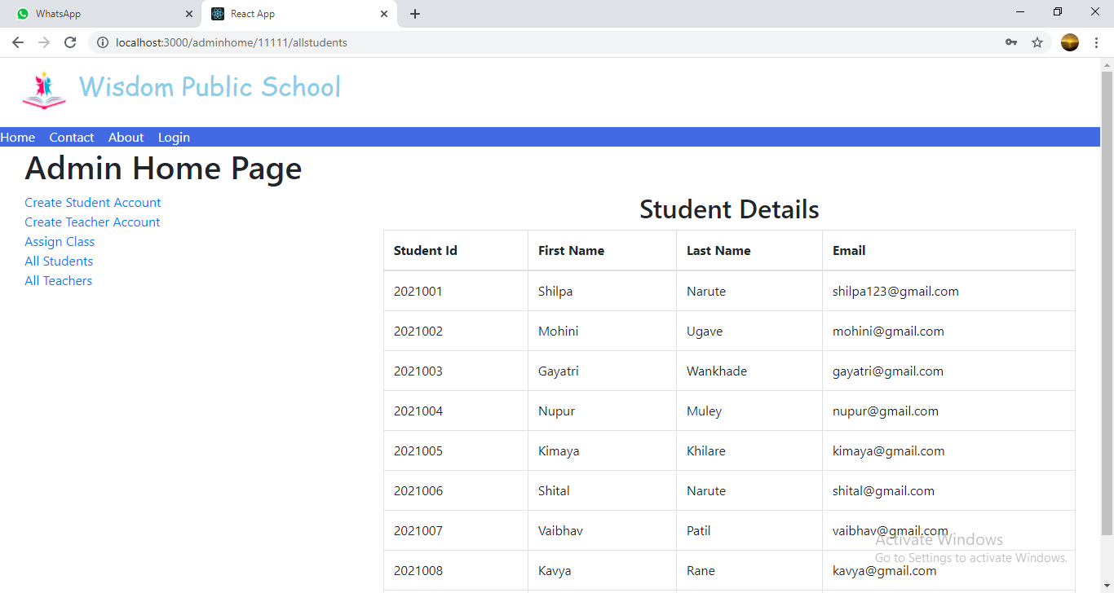

**8.5.5 All Teachers List**

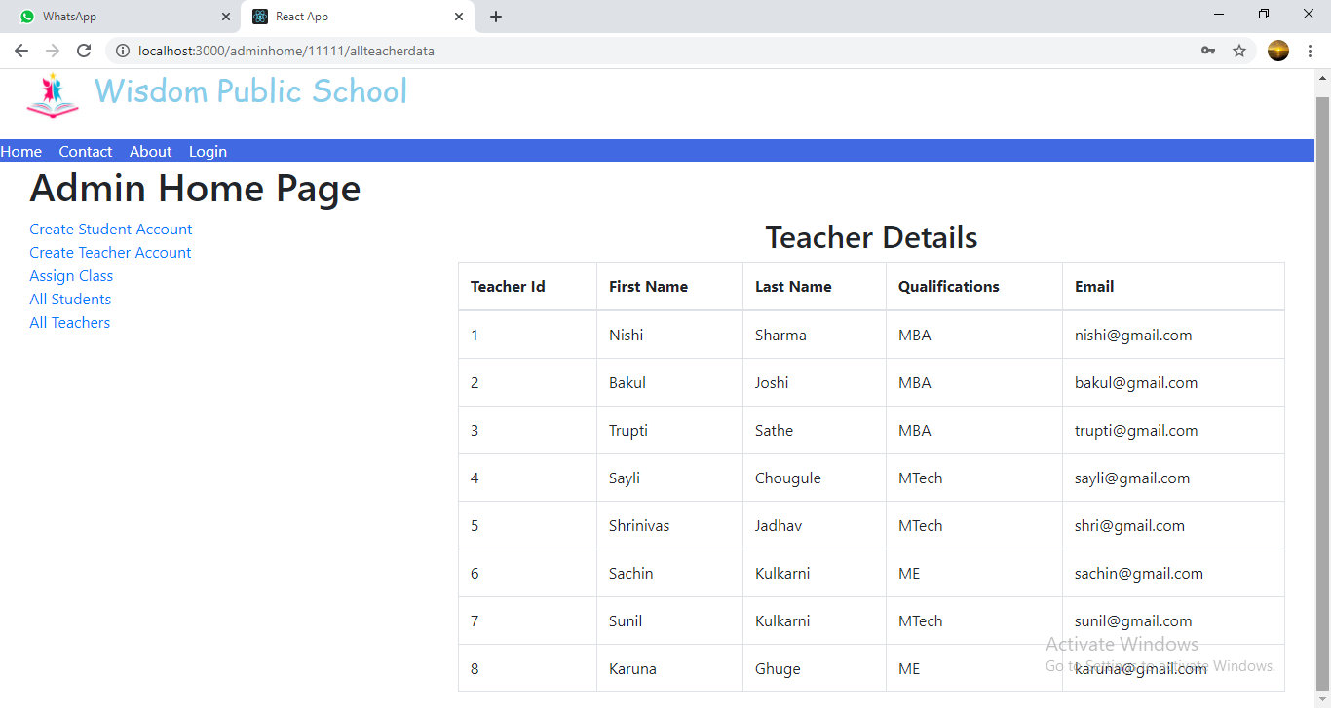

**8.6 Teacher Home Page**

**8.6.1 Upload Study Material Page**

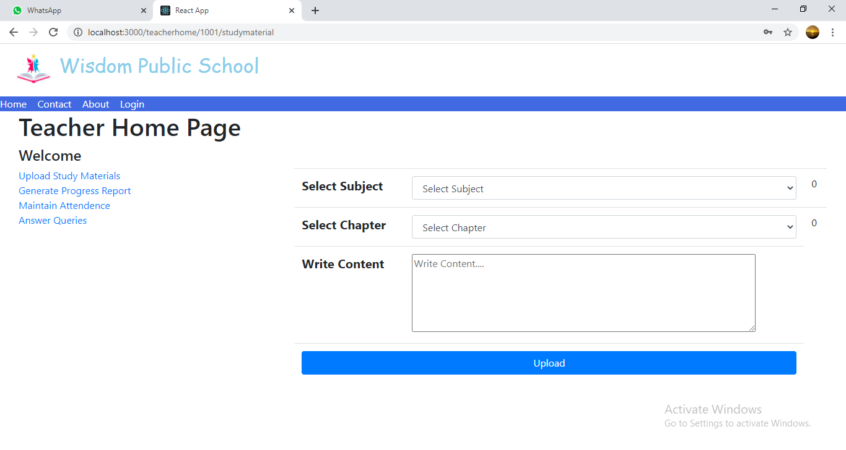

**8.6.2 Generate Progress Report Page**

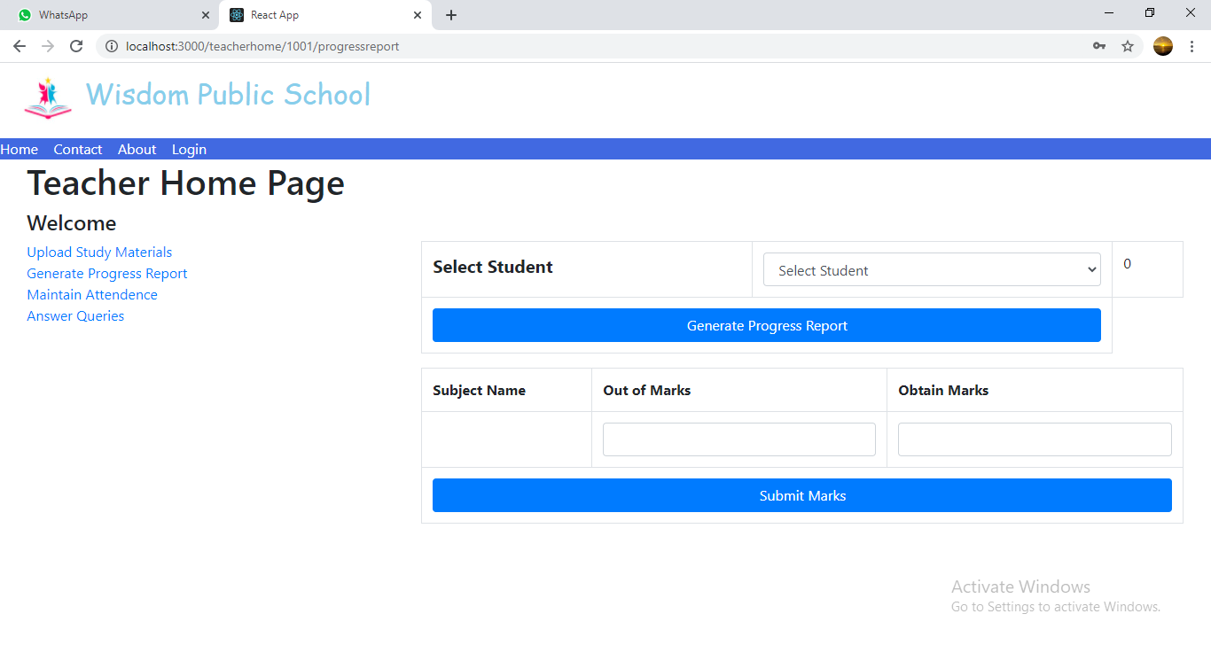

**8.6.3 Maintain Attendance Page**

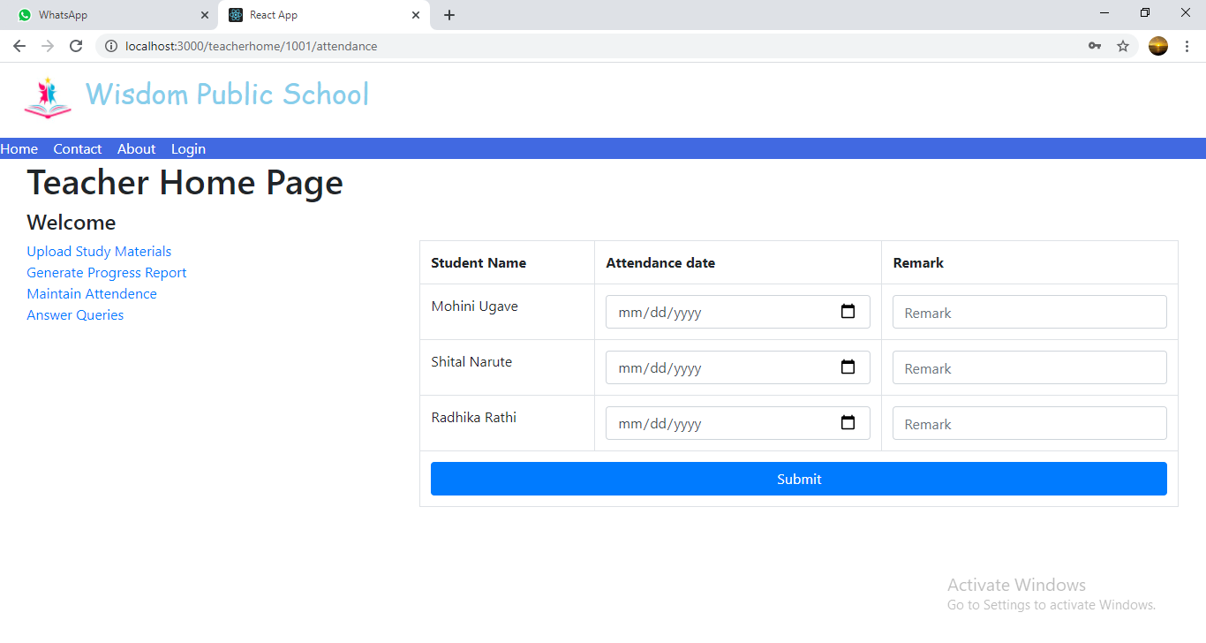

**8.6.4 Answer Queries Page**

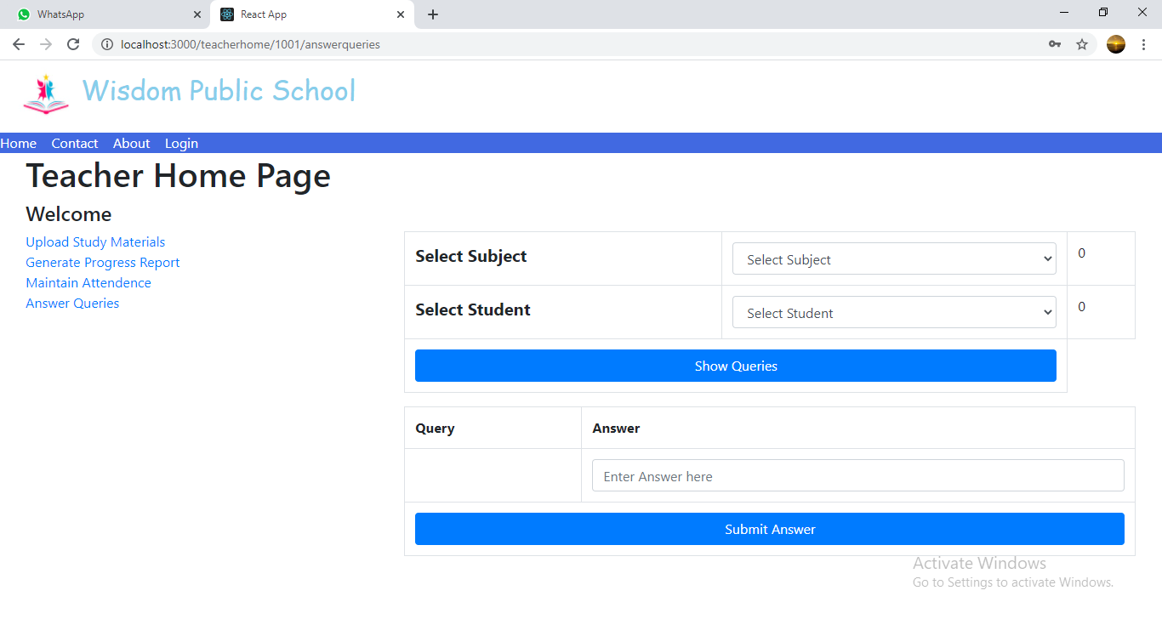

**8.7 Student Home Page**

**8.7.1 View Study Material Page**

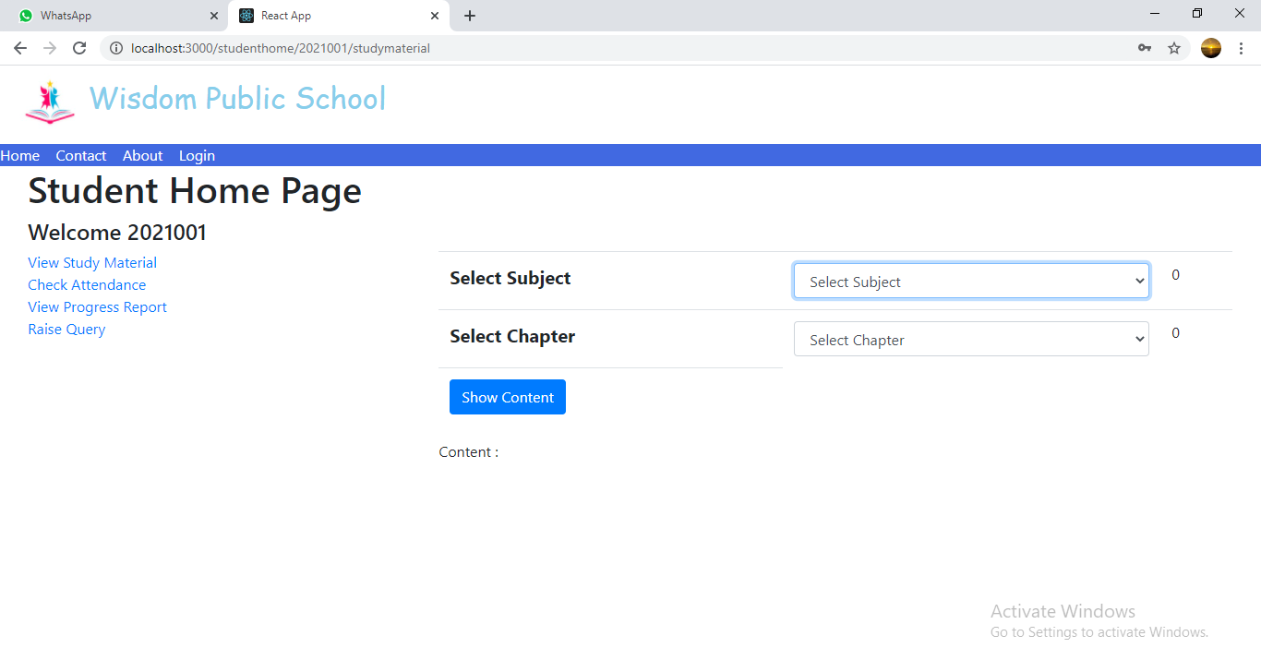

**8.7.2 Check Attendance Page**

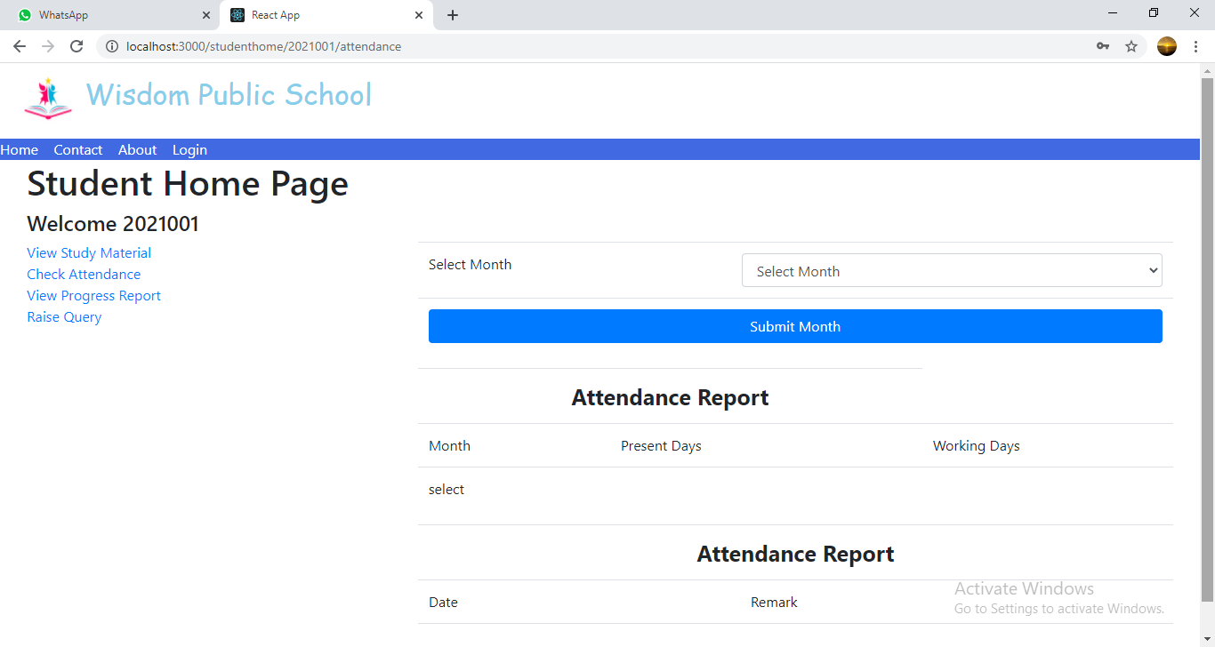

**8.7.3 View Progress Report Page**

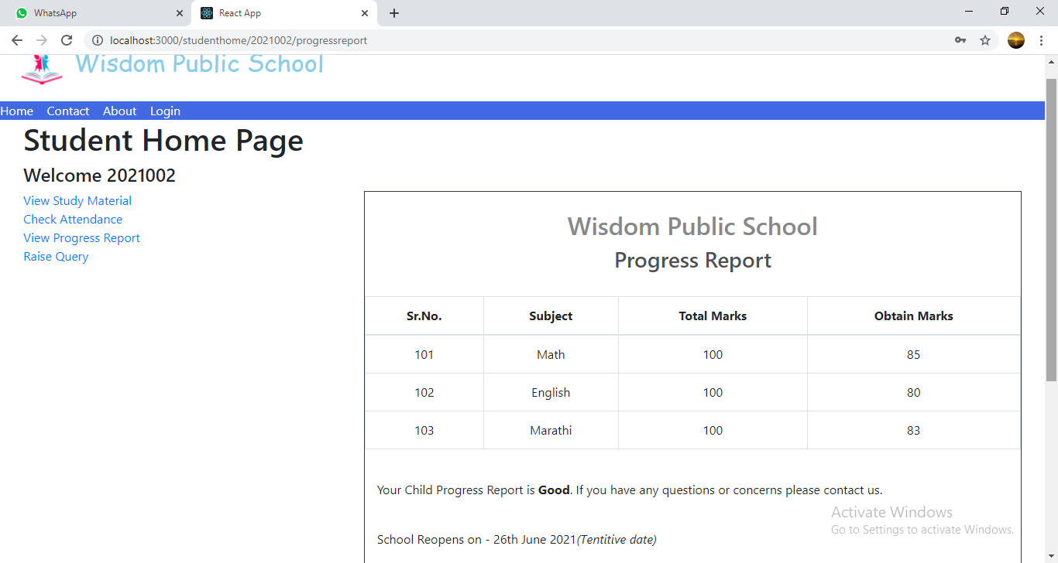

**8.7.4 Raise Query Page**

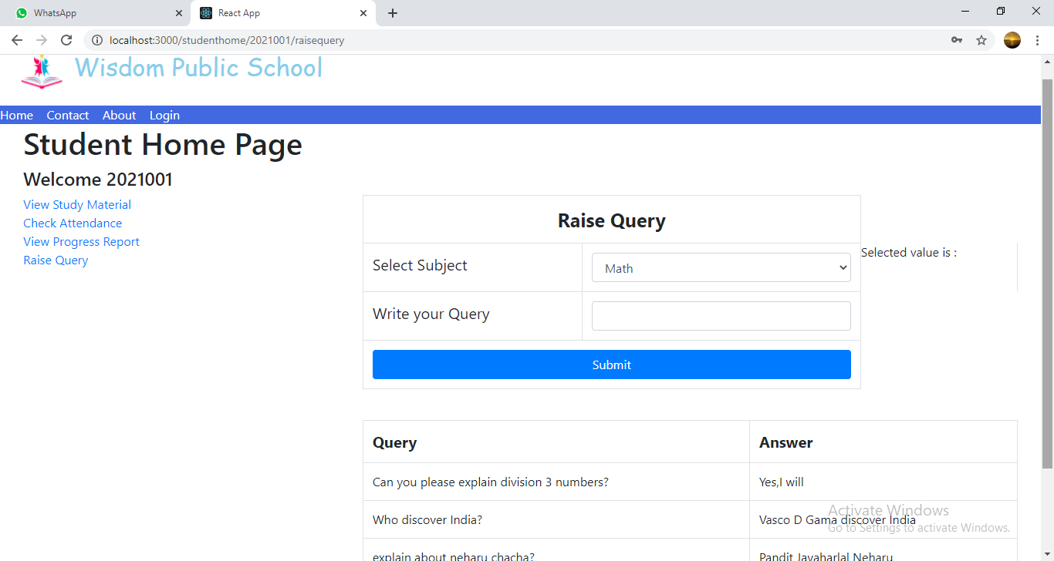

**9. CONCLUSION AND FUTURE SCOPE**

Paperless School Management System provides better education and platform to get connected with Teachers and Students efficiently.

Our System provides a very user-friendly platform where Student can easily read the study materials, check the attendance, raise the queries and view progress report, also Teacher will upload study materials, maintain attendance, answer queries and generate progress report.

Our system is aimed efficient management of various tasks like Generating time table for students on daily basis, Managing fees payment, Examination management. Digitally monitor daily activities along with managing all the resources and information on a single platform.